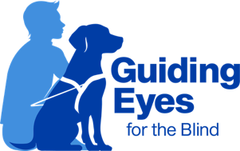
Chapter 32: Photos
During class, we will take a team photo of you and your dog, as well as a class photo. The photos are portrait-style and are suitable for framing. A small version of the portrait will be placed on the ID card that we give you when you go home. Your dog’s puppy raisers will also receive a copy of the portrait photo.
What to wear: You should dress in neat, clean clothing. You may choose to “dress up” for the occasion, but casual clothing is fine as well. Bright colors generally look very nice in photos. We do not recommend wearing only white, as it can make the picture look washed out. A white shirt with a print or with a jacket and tie is fine.
For the photo of you and your dog, you will be seated on a low table with your dog in a harness sitting next to you. We will ask you to position yourself in a specific way, and the instructors are on hand to help position your dog. Several shots will be taken so we can pick the best one. We might whistle or make noises to get your dog's attention. If your dog moves or breaks position, do not attempt to hold them in place. We will just pause for a moment and give everyone a chance to get repositioned.
You will receive the following photos free of charge:
• 1 - 5 X7 of you and your dog
• 1 - 5X7 class photo

If you would like more copies of your photo, please let us know. We would be happy to email you a copy of your photo for you to print out at home.

Updated July 2024

